**Data Analysis on School Performance**

Since the late 1980s, Charter schools took the market and have been thriving ever since. Even though both District schools and Charter schools are similar in nature as both are Tuition Free and publicly funded, the analysis on the given data shows that Charter schools’ performance is better in comparison to Districts schools’ performance.

The % Overall Passing for Charter school is 90.43 which is far greater than the District School’s number- 53.67. The Charter school exceeds District school in terms of Average Math Score, Average Reading Score, % Passing Math and % Passing Reading as seen in the above snippet.

If we look at the top 5 highest performing schools and bottom 5 lowest performing schools in terms of ‘% Overall Passing’, it is seen that all the top 5 highest performing schools fall under Charter School type and all the 5 lowest performing schools fall under District School type.

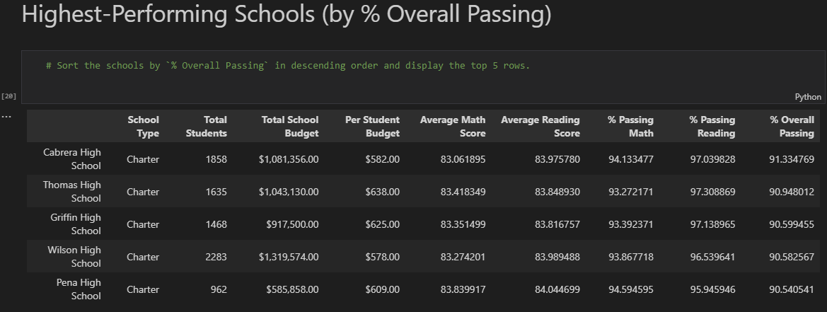

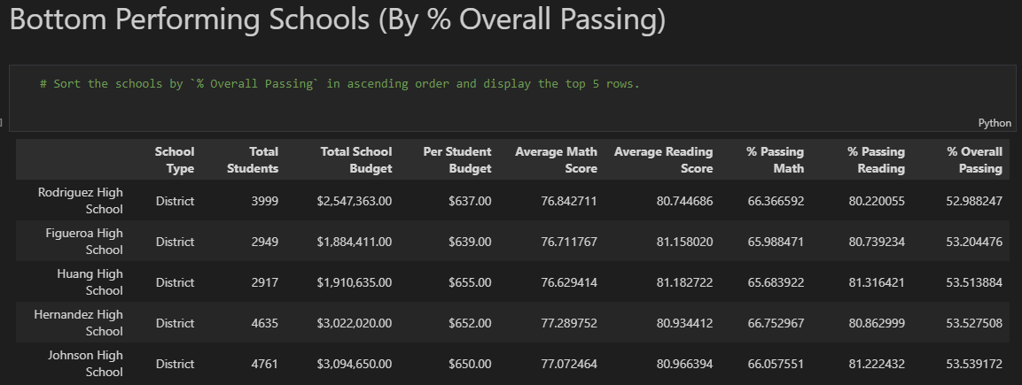

The data analysis also reveals that the small and medium sized school’s performance is better than the large sized schools’ performance. There is a huge gap in numbers between Large sized school Versus Small and Medium sized school for % Overall passing which is 58.29% vs 89.88% and 90.62%. The Small and Medium sized school excels the Large sized school in terms of Average Math Score, Average Reading Score, % Passing Math and % Passing Reading as in the snippet below.

Another major notice in the data analysis is that the schools with the smallest budget (585 dollars or lower) per student performed better compared to the school with highest budget (645- 680 dollars) per student in terms of all measuring factors as in the given snippet below.

The huge discrepancy can be seen in the % Overall Passing which is 90.37% versus 53.53% for the smallest budgeted schools and Highest budgeted schools respectively. The snippet also shows that as the budget increases, there is a decline in the scores as well as percentages of all measuring factors.

Even though a large amount of data has been provided for analysis, there are some limitations to it. Charter schools accept only a limited number of students whereas District schools have no limitations. The smaller number of students in Charter schools may have been a factor in their excellence. This factor has not been embraced in this analysis. The excellence of the schools also depends upon other factors such as the qualifications and capabilities of the teachers, the management team, the discipline/ character of the students etc., which are not a part of this analysis.